Simulation of
A Second-Order
System

By: David Clarke
Course: Electrical & Electronic Engineering2
Date:26/5/2000

- Abstract

It can be shown through a systematic approach, the behaviour of a Second-Order system can be analysed. The use of an analogue computer, incorporating ideal integrators, is used to simulate this ideal second order system. When excited with an input U the response of the system X can be examined, knowing full well what the transfer function of the system is the damping ratio can be calculated.

- Introduction

H (s)
U
X

In the simple system shown the transfer function for a second-order system is given by

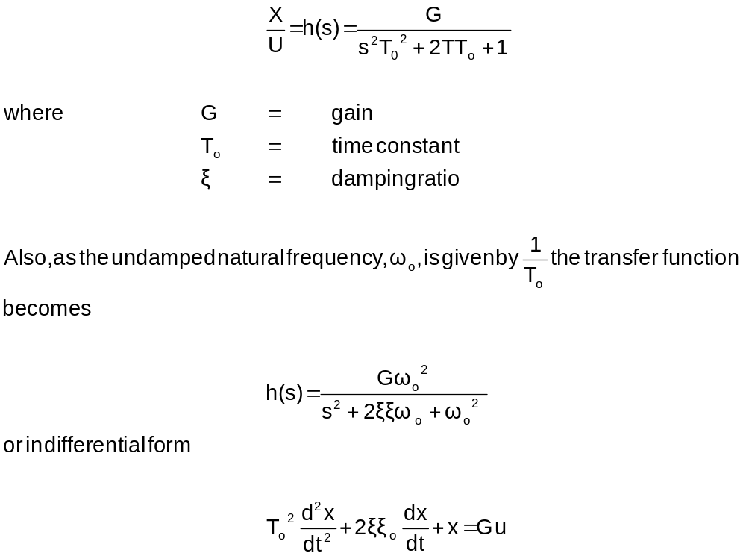

- Results

a). Set up the circuit as shown above with G = 2, T₀ = 2s and ζ = 0.2. Set the integrator time constant to 1 by appropriate selection of R and C values.

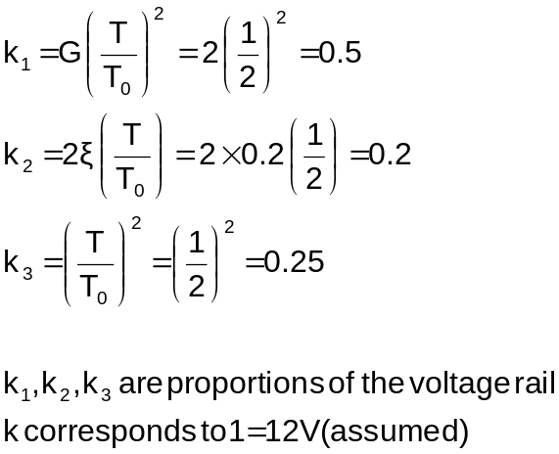

b). Observe the output ‘x’ on the analogue computer and if necessary reduce the gain value to prevent the output saturating.

To overcome saturation the following values of k were altered:

K₁ was reduced to 0.15
K₂ was kept at 0.2
K₃ was kept at 0.25

c). Step Response

Using a chart recorder record the step response with constant U and zero initial conditions. Vary k₂ and note the effect of a change in the damping ratio. Record the step response for at least 3 values of k₂.

From the plots estimate the undamped natural frequency and the damping ratio.

K₂ | 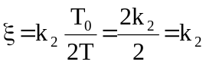
(1) 0.2 | (1) 0.2
(2) 0.5 | (2) 0.5
(3) 0.8 | (3) 0.8

- K₂ = 0.2
i)
X_{ss}
H₂
τ
H₁

τ = 2.65 x 5 = 13 sec
h₁ = 3.4V
h₂ = 1.0V
X_{ss} = 6.0V

ii)
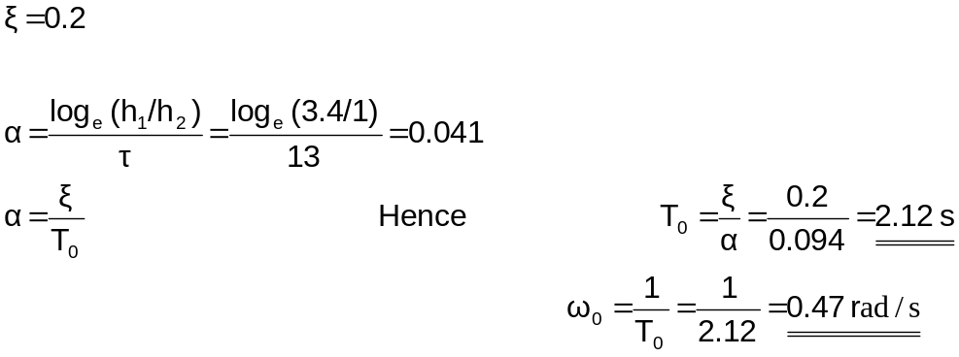
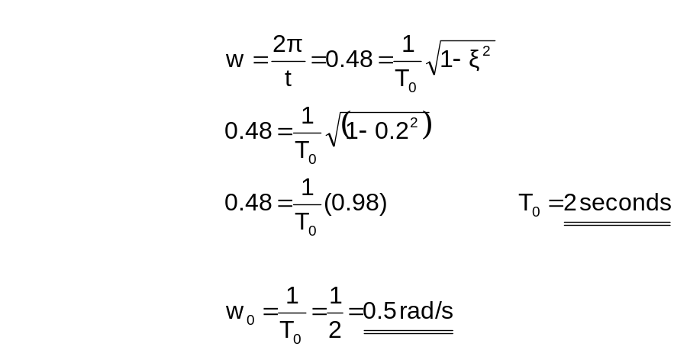

- k₂ = 0.5
(i)

X_{ss}
τ
H₁
H₂

τ = 2.5 x 5 = 12.5 sec
h₁ = 1V
h₂ = 0.2V
X_{ss} = 6.0V

(ii)

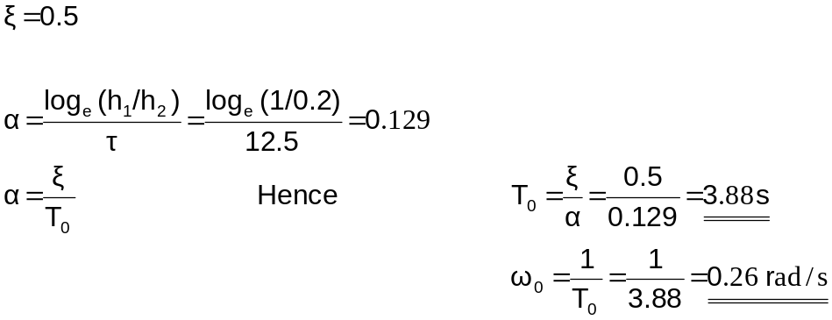

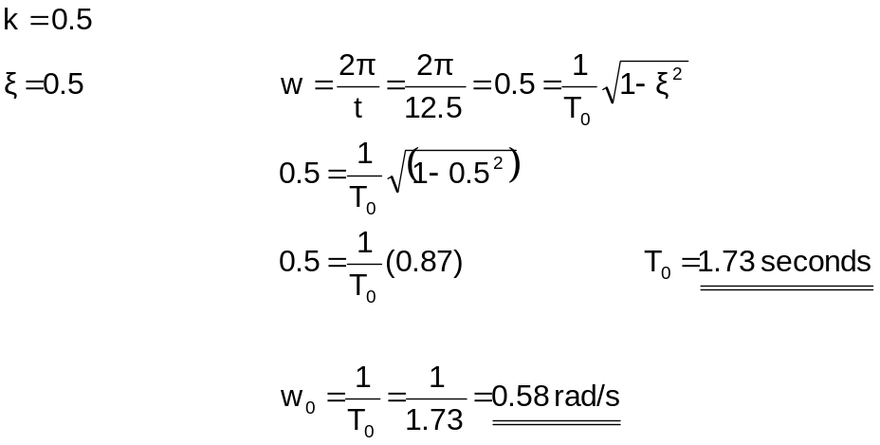

- k₃ = 0.8
(i)
τ
H₂
X_{ss}
H₁
τ = 15 sec (difficult to estimate)
h₁ = 80 mV
h₂ = ?V
X_{ss} = 6.0V

(ii)

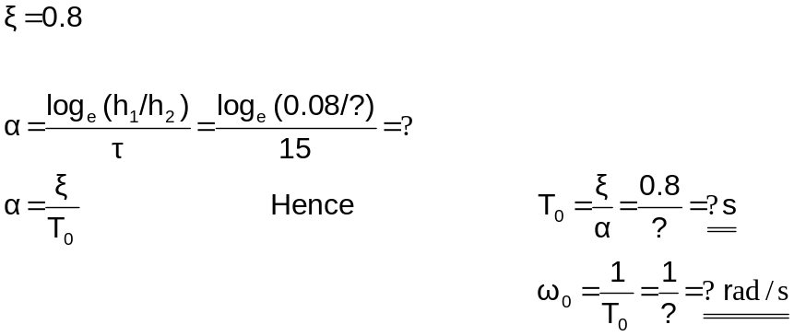

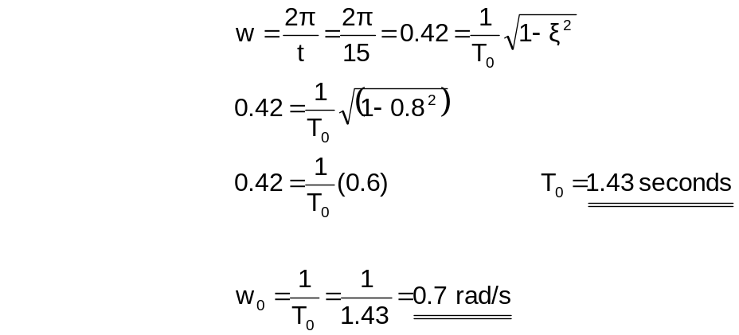

d). Frequency Response

Change the time constant of the integrators to one tenth of the value used in ©. Using the signal generator apply a sinusoidal input U and measure the magnitude and phase of the frequency response over the frequency range 0.2 – 2.0 Hz. The oscilloscope x and y plates allow the output signal to be compared with the phase delayed signal.

Estimate the undamped natural frequency and the damping ratio from the frequency response locus.

Time Constant =CR
To achieve one tenth the time constant of the integrators, 0.1 farad capacitance is used instead of the 1 farad capacitance.

Frequency (Hz) | Phase (∅) | Amplitude (V)
0.2 | 26 | 2.14
0.4 | 49 | 2.02
0.6 | 72 | 1.70
0.8 | 92 | 1.36
1.0 | 106 | 1.06
1.2 | 116 | 0.760
1.4 | 124 | 0.576
1.6 | 133 | 0.464
1.8 | 137 | 0.396
2.0 | 141 | 0.316

Utilising the locus diagram
W = w₀
w
M₁
M₀
W₀ = 0
a).

When the phase angle is -90°
Undamped natural frequency w = w₀ = 0.8 rad/s

b).

M₀ = 1.37 V
M₁ = 1.37 V

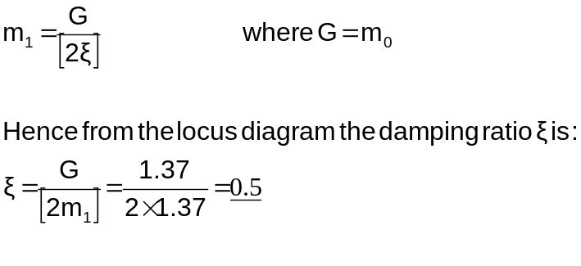

- Discussion of Results and Conclusion

The analogue computer simulates a second order system accurately. When stimulating the system with a step response, increasing the value of k₂ (which increases the potential dropped across it) increases the value of the damping ratio. The undamped natural frequency and the damping ratio taken from the frequency response were 0.8Hz and 0.5 respectively. Comparing these results with that obtained from the step response results of part © it can be seen that this corresponds to the step response of the second recorded value of k₂. Hence there is a distinct relationship between the frequency response and the step response.

